# LPL Portal Update (SortRefer)

Information of Server and Login Credential and Process -

**Bot Development Server -**

**SortRefer URL - https://supplier.sortrefer.co.uk/**

**SortRefer Username - support2@lpropertylawyers.co.uk**

**SortRefer Password - Mohini@123**

**Hoowla URL –**

**Hoowla Username-**

**Hoowla Password –**

**PDD Made By: Ravi Rawal**

1. Login to hoowla website.

1. Login to SortRefer website.

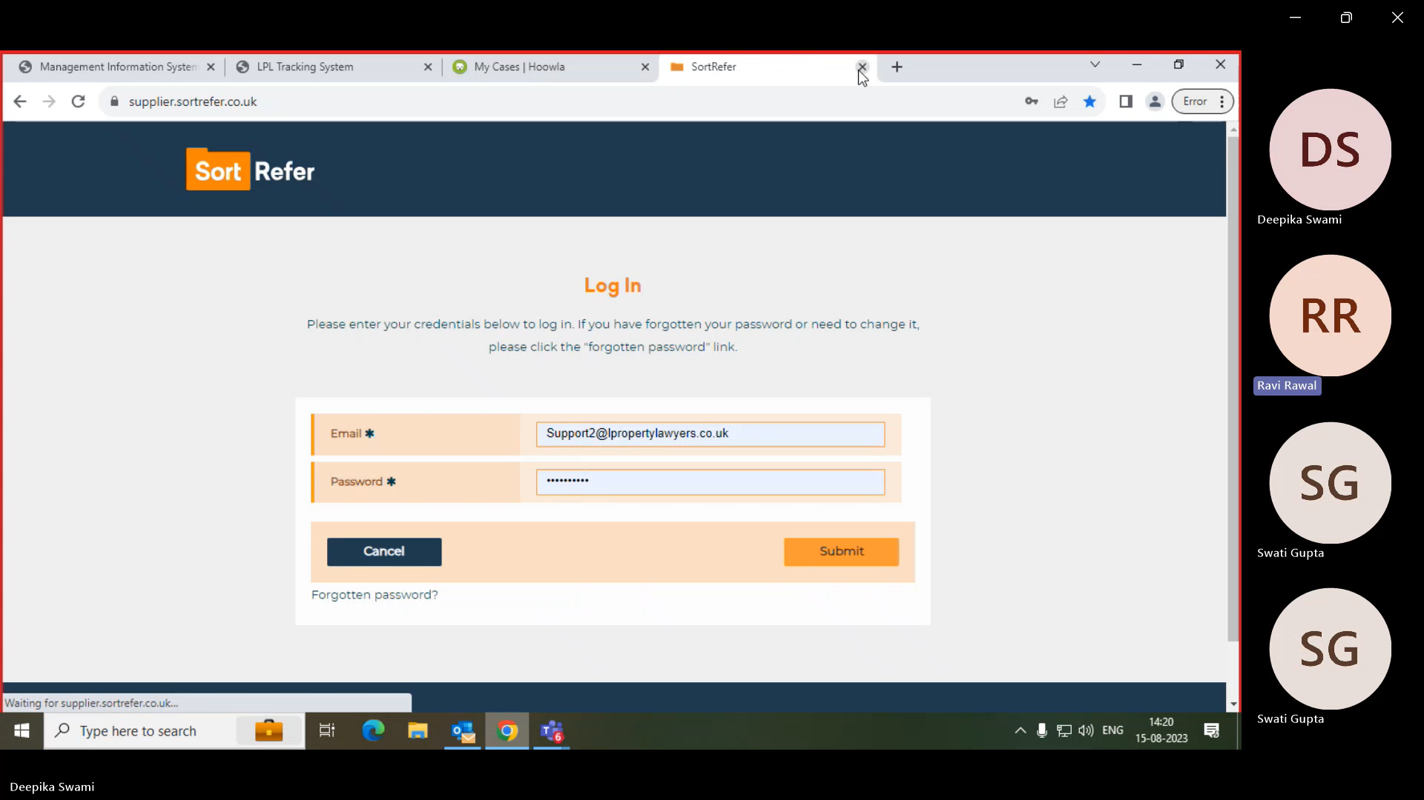

1. Search for Case references and click on view.

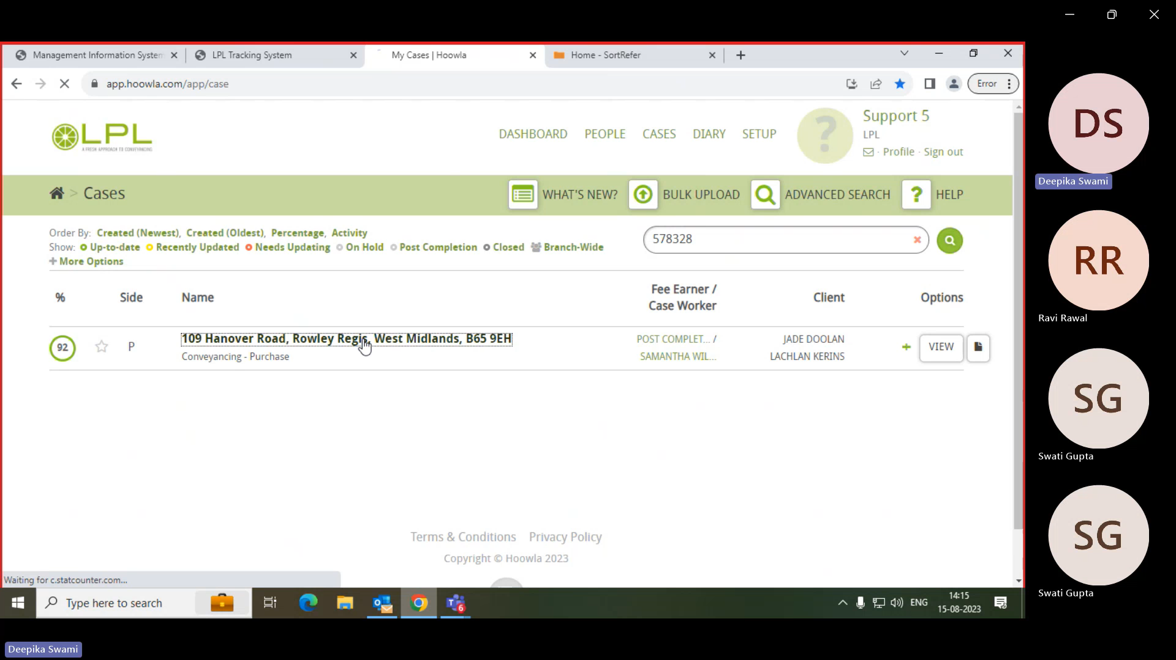

1. Extract the Client Name.

1. Extract the Completion Date.

(Condition – If the completion date provided is a date in the future, then bot will encounter an error [Business Exception] in this scenario.)

1. Click on “Home" section, then proceed to "Case search." Once there, enter the surname into the search bar.

(Condition – If the case is not found under the first client's surname, proceed to search using the second client's surname.)

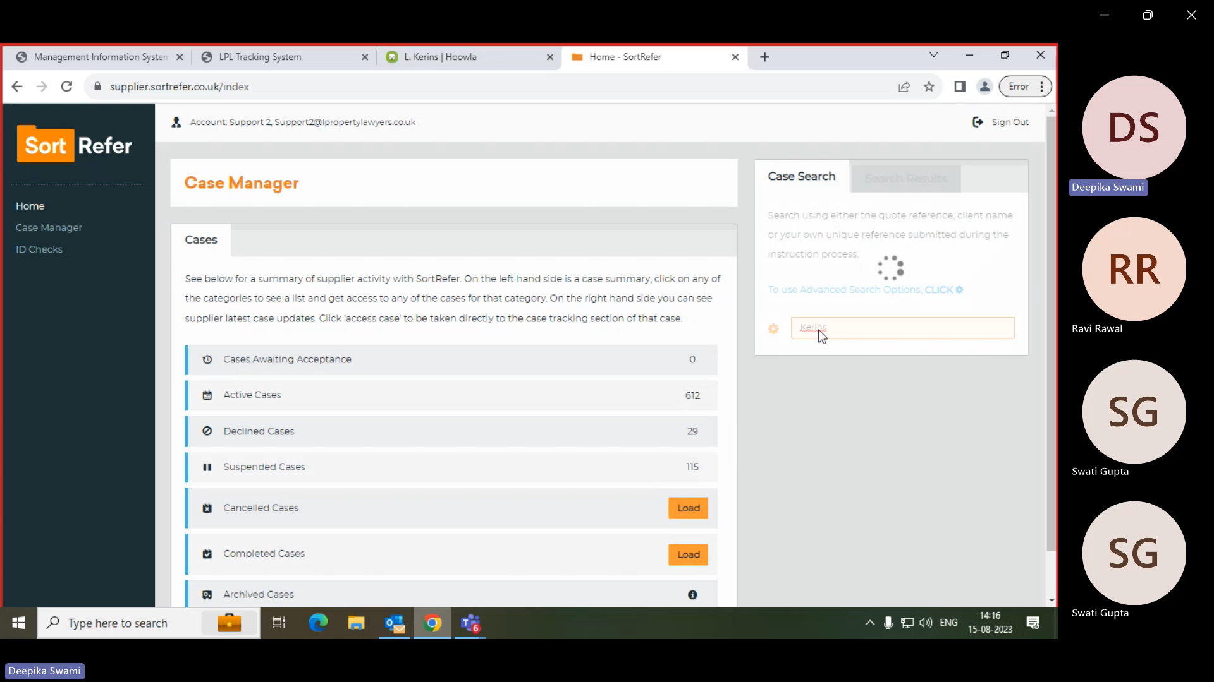

1. Click on the Access Case.

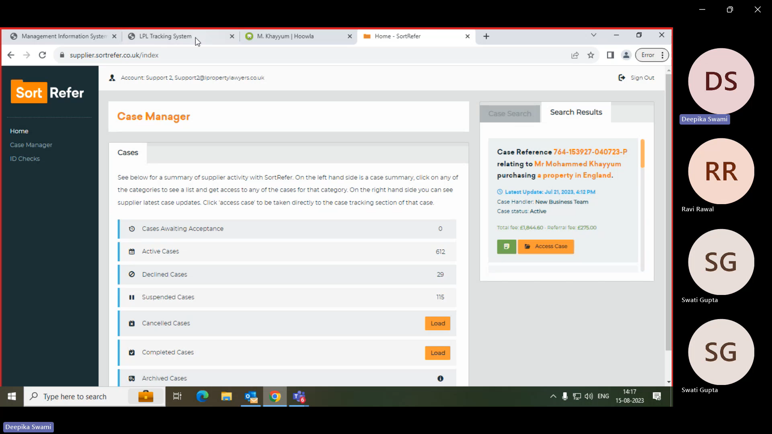

1. If the Supplier Reference matches the Hoowla reference number, then proceed to click on the "Completed Case" option.

(Condition – In certain instances, the "Completed Case" option may have already been clicked)

